Tejaswini SE

1RVU22BSC105

**Lab 3: Extending the website with new features in the submenu**

1. The website is built using HTML. The page is split into sections navigation menu, product categories and contact forms.
2. Navigation menu at the top where users can click on options like Men, Women, Kids, Sports and Contact Us.
3. Each of these categories has a submenu that opens when clicked.
4. Product categories have different collections of shoes for Men, Women, Kids, and Sports.
5. Three forms are created general inquiry, feedback and order support form.

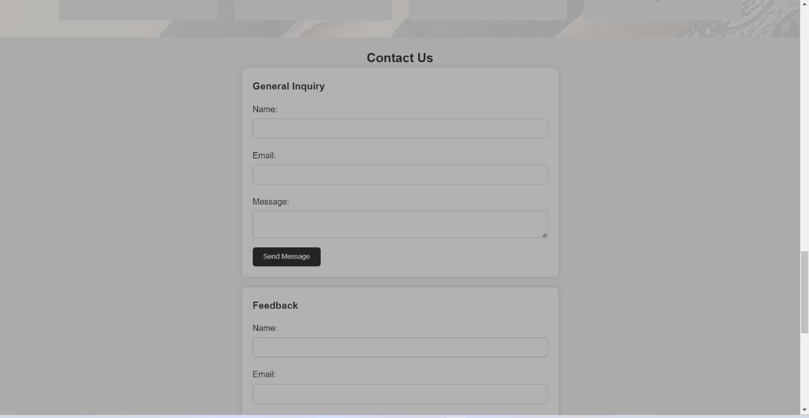

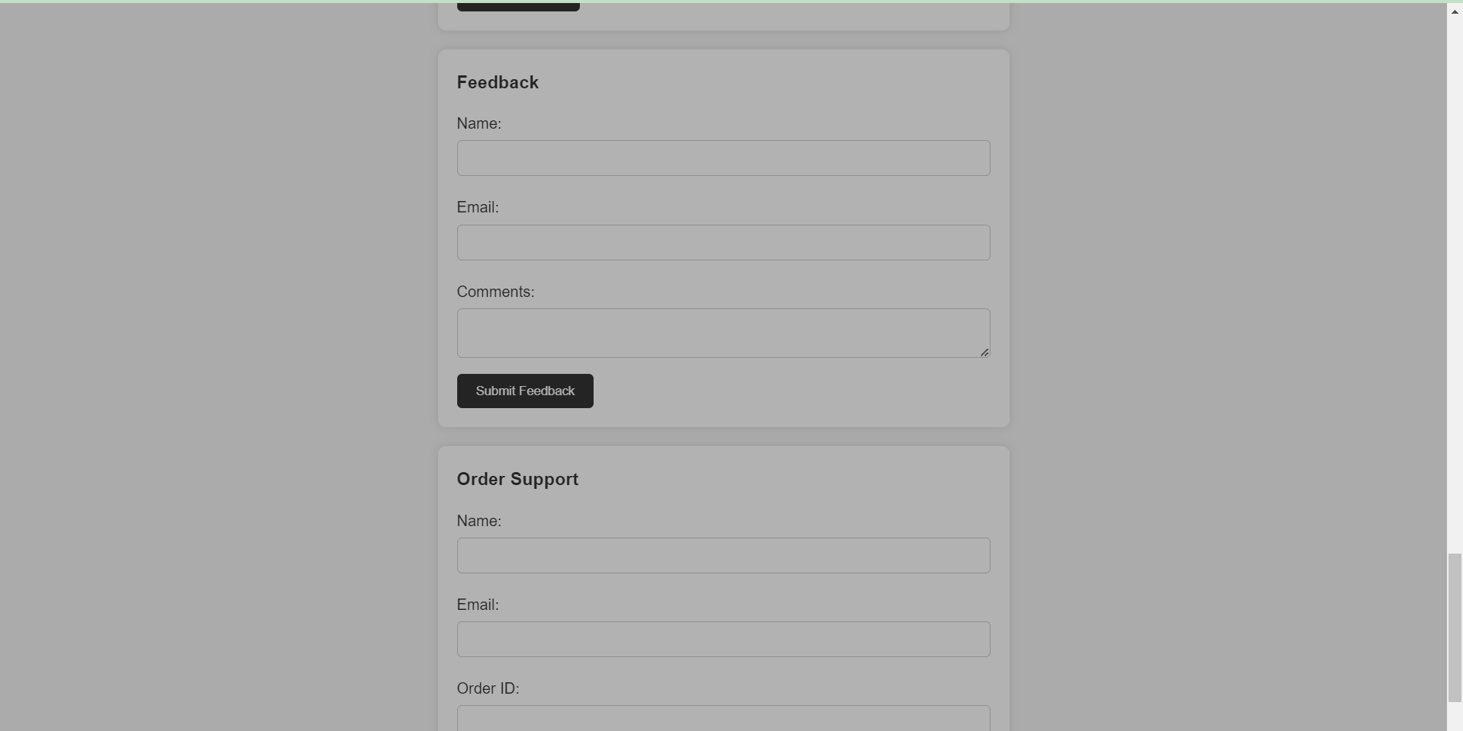

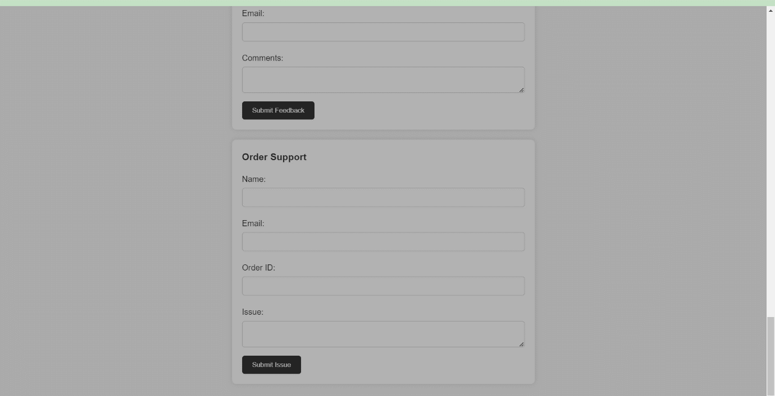

**Code:**

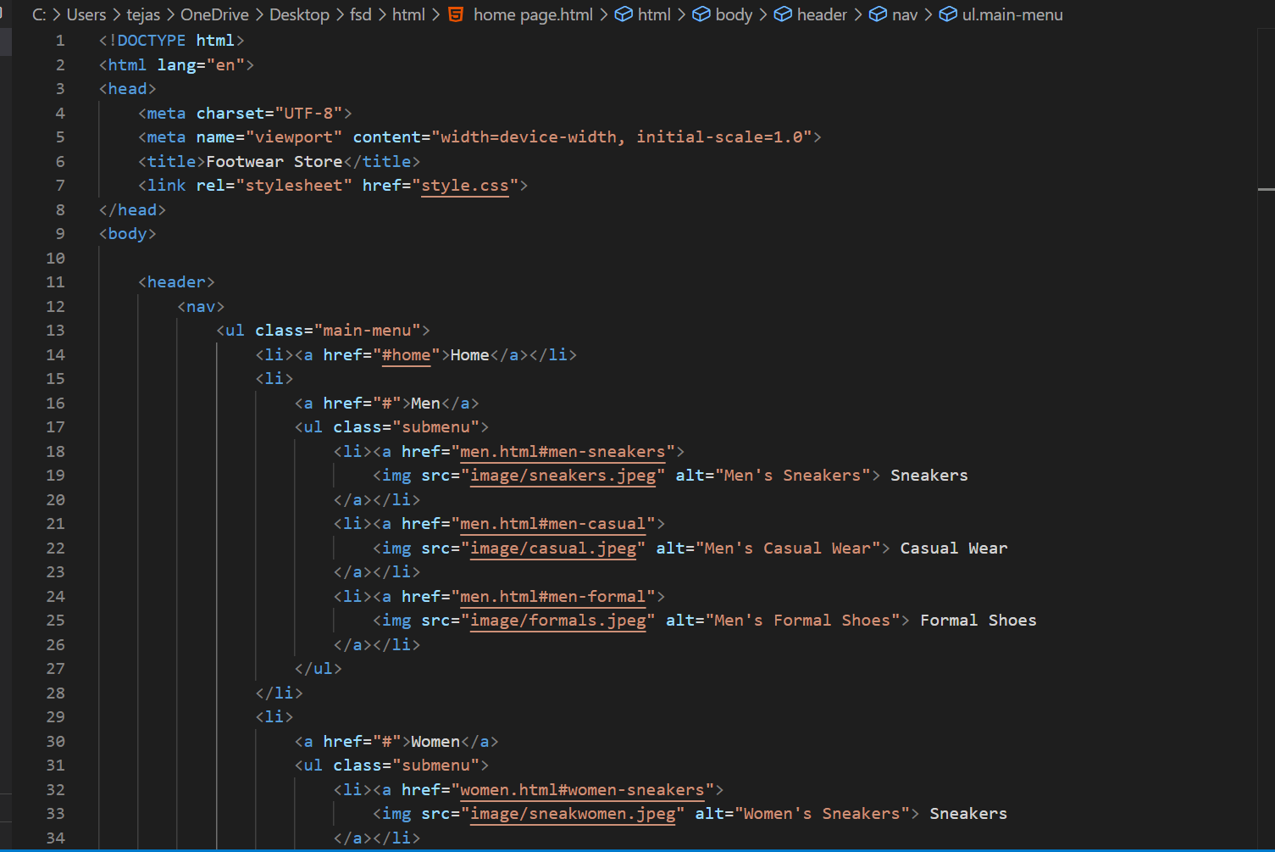

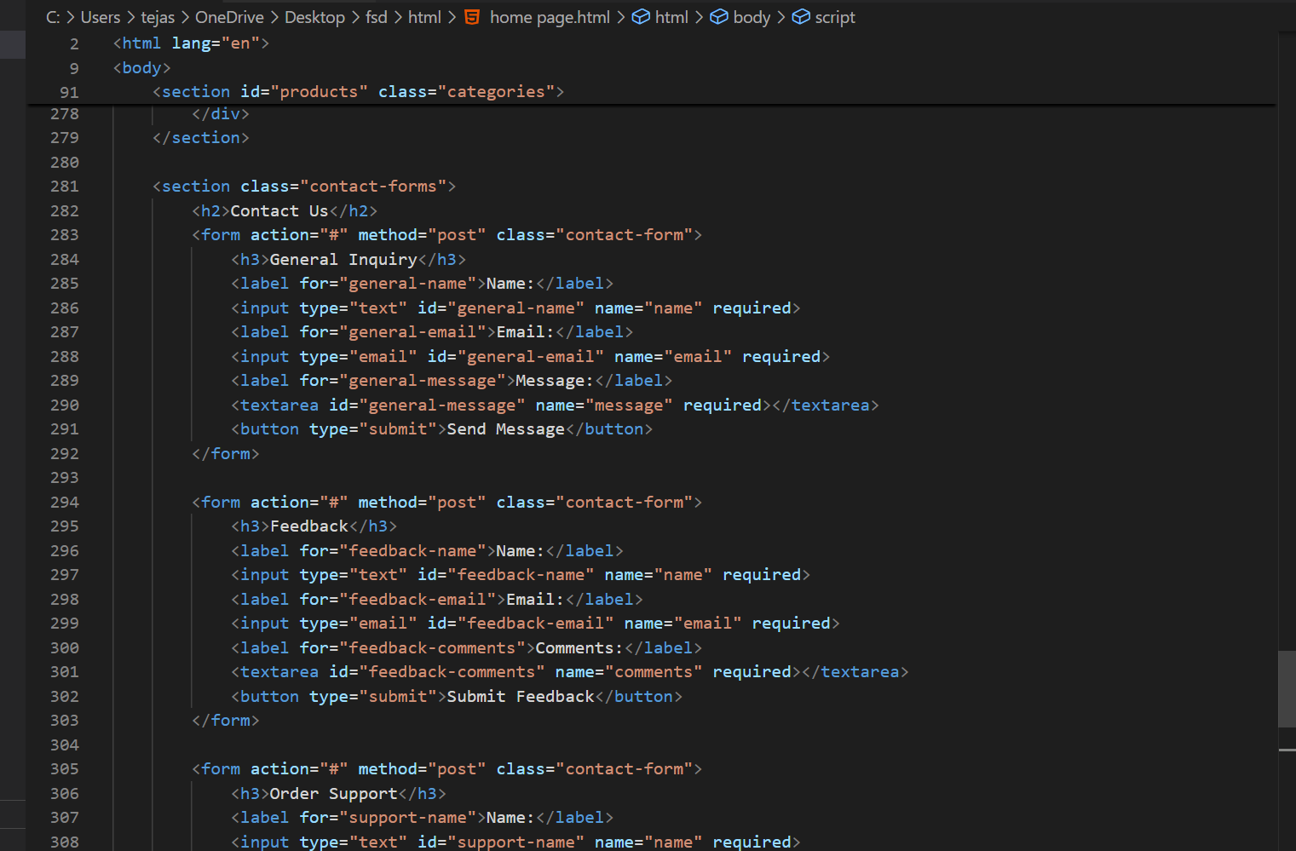

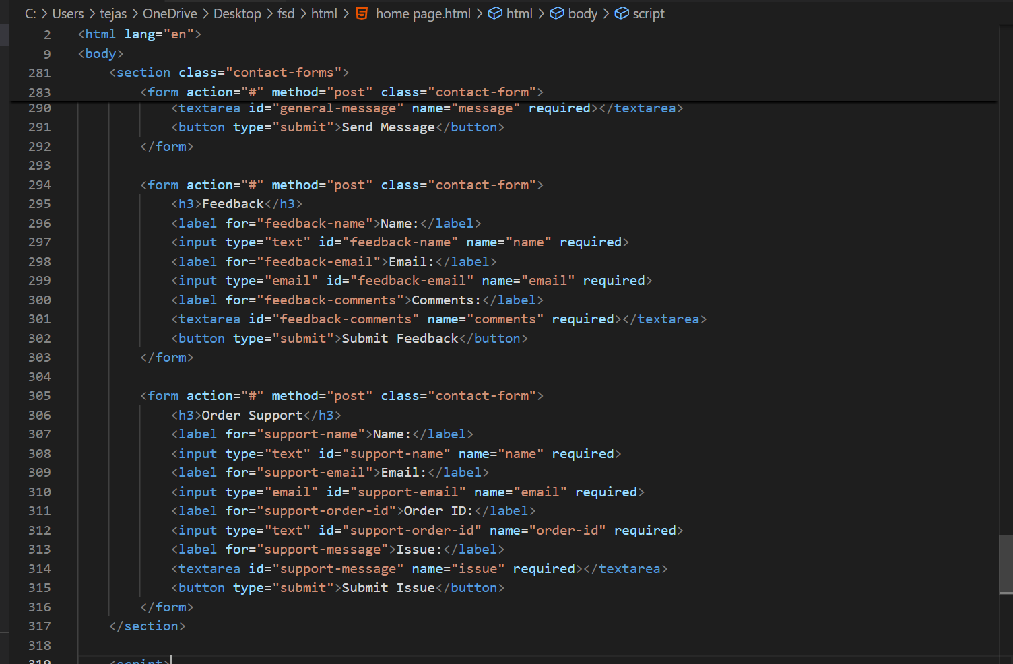

CSS: 